**Machine Learning**

**& Deep Learning Demystified**

**A Beginner's Guide to Core Concepts and Fundamentals**



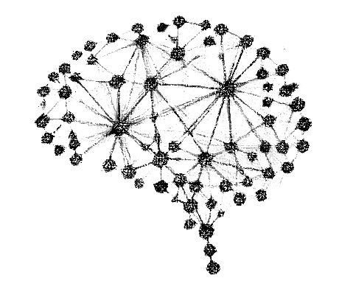

**Leníkia Ouana**

**Index**

**Preface**

Why This Book Was Written

Who This Book Is For

How to Use This Book

**Chapter 1: Artificial Intelligence (AI)**

What Is AI?

Why AI Matters

Types of AI (Capabilities & Functionalities)

Branches of AI:

* Machine Learning (ML)
* Natural Language Processing (NLP)
* Computer Vision
* Robotics
* Expert Systems
* Deep Learning (DL)
* Fuzzy Logic
* Evolutionary Computation
* Swarm Intelligence
* Cognitive Computing

**Chapter 2: Machine Learning (ML)**

What Is Machine Learning?

A Simple Analogy

Types of Machine Learning

* + Supervised Learning
  + Unsupervised Learning
  + Semi-Supervised Learning
  + Reinforcement Learning

ML Tasks

* + Classification
  + Regression
  + Clustering
  + Dimensionality Reduction
  + Anomaly Detection
  + Recommendation Systems

**Chapter 3: Core ML Concepts**

What Is an Algorithm?

Comparison to Traditional Programming

Popular Algorithms by Type

* + Linear & Logistic Regression
  + Decision Trees & Random Forest
  + SVM
  + K-Nearest Neighbors
  + K-Means Clustering
  + PCA
  + Naive Bayes
  + Gradient Boosting (e.g., XGBoost)
  + Ensemble Methods
  + Neural Networks (Basic)

Datasets

* + Types by Structure
  + Types by Label Availability
  + Dataset Roles (Train/Validation/Test)

Modules

* + Data Handling
  + Data Visualization
  + Model Building
  + Model Evaluation
  + Deployment Tools

# Models

* Types of Models in Machine Learning

Algorithm vs Dataset vs Module vs Model

**Chapter 4: How a Machine Learning Project Works**

10 Steps in a Real ML Workflow

* + Define the Problem
  + Collect the Data
  + Explore the Data (EDA)
  + Prepare the Data
  + Choose a Model
  + Train the Model
  + Evaluate the Model
  + Improve the Model
  + Deploy the Model
  + Monitor and Maintain

**Chapter 5: Deep Learning Demystified**

What Is Deep Learning?

How It Differs from Traditional ML

Why It’s Powerful

How Neural Networks Work

* + Forward Pass
  + Loss Function
  + Backpropagation
  + Optimizers
  + Epochs and Batches
  + Overfitting vs Underfitting

**Chapter 6: Deep Learning Architectures**

Why So Many Architectures Exist

Strengths of Each Architecture

* Feedforward Neural Networks (FNN)
* Convolutional Neural Networks (CNN)
* Recurrent Neural Networks (RNN)
* Long Short-Term Memory (LSTM)
* Gated Recurrent Units (GRU)
* Autoencoders
* Generative Adversarial Networks (GANs)
* Transformer Networks

**Chapter 7: Real-World Applications**

1. Healthcare
2. Finance
3. Transportation
4. Retail & E-commerce
5. Marketing
6. Agriculture
7. Manufacturing
8. Education
9. Security

**Preface**

This book has one simple goal. To explain the core concepts of Machine Learning and Deep Learning in the clearest, simplest, and most intuitive way possible. No intimidating math. No unnecessary jargon. Just clear explanations, helpful analogies, and examples that actually make sense.

You will not become an expert by the last page, but you will build a solid foundation. You will gain the confidence to explore more advanced books, take on new challenges, and begin your own journey into the world of AI with clarity.

# **Chapter 1:**

# **Artificial Intelligence (AI)**

Artificial Intelligence, or AI, is a field of computer science focused on building machines that can think and act in ways that seem intelligent. In simple terms, AI is about teaching computers to do things that usually require human intelligence. These things include understanding language, recognizing images, making decisions, solving problems, and learning from experience.

# **Why is Artificial Intelligence important?**

AI is already part of our everyday lives. When your phone suggests words while you're typing, when Netflix recommends a movie, or when you talk to a virtual assistant like Siri or Alexa that’s AI in action. AI helps businesses make smarter decisions, doctors diagnose diseases, and even self-driving cars navigate roads.

# **Types of Artificial Intelligence**

# **1.**[**Based on Capabilities**](https://www.geeksforgeeks.org/types-of-artificial-intelligence/#types-of-ai-based-on-capabilities)

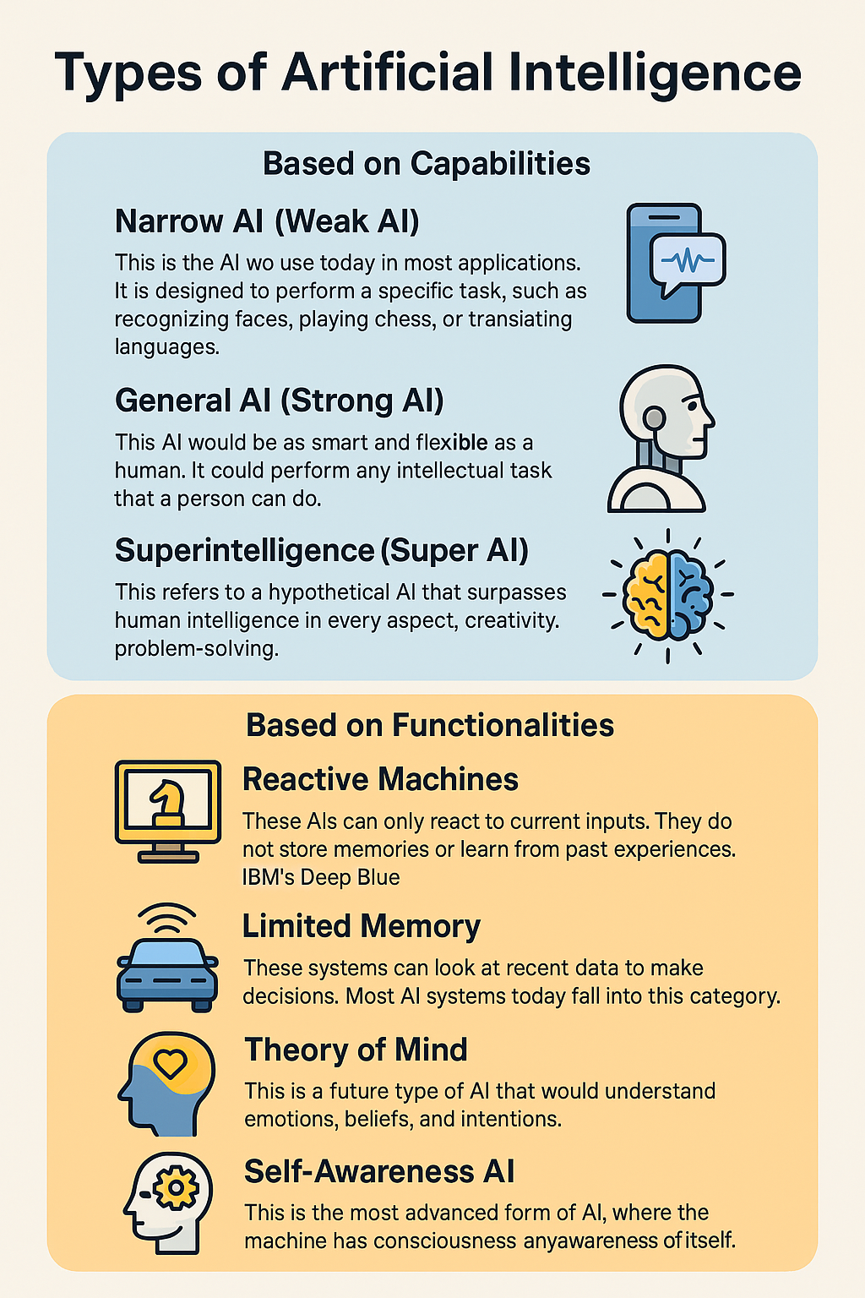

# **2.**[**Based on Functionalities**](https://www.geeksforgeeks.org/types-of-artificial-intelligence/#types-of-artificial-intelligence-based-on-functionalities)



# **Branches/Subsets of Artificial Intelligence**

[**1.Machine Learning (ML)**](https://www.geeksforgeeks.org/top-10-branches-of-artificial-intelligence/#machine-learning-ml)**:** The most popular branch of AI today. It involves teaching machines to learn patterns from data and make decisions or predictions.

**2.**[**Natural Language Processing (NLP)**](https://www.geeksforgeeks.org/top-10-branches-of-artificial-intelligence/#natural-language-processing-nlp)**:** Enables computers to understand, interpret, and generate human language. Example: Chatbots, language translation, sentiment analysis.

**3.**[**Computer Vision**](https://www.geeksforgeeks.org/top-10-branches-of-artificial-intelligence/#computer-vision)**:** Helps machines to interpret and understand visual information from the world. Example: Facial recognition, image classification.

**4.**[**Robotics**](https://www.geeksforgeeks.org/top-10-branches-of-artificial-intelligence/#robotics)**:** Combines AI with mechanical engineering to create intelligent machines that can move and interact with the environment. Example: Industrial robots, robotic assistants.

**5.**[**Expert Systems**](https://www.geeksforgeeks.org/top-10-branches-of-artificial-intelligence/#expert-systems)**:** Simulate the decision-making ability of a human expert. Used in fields like medicine, engineering, and finance.

**6.**[**Deep Learning**](https://www.geeksforgeeks.org/top-10-branches-of-artificial-intelligence/#deep-learning) **(DL):** A specialized form of Machine Learning using artificial neural networks with many layers. It is very effective in recognizing patterns in complex data like images, speech, and text.

**7.**[**Fuzzy Logic**](https://www.geeksforgeeks.org/top-10-branches-of-artificial-intelligence/#fuzzy-logic)**:** Deals with reasoning that is approximate rather than fixed and exact. It allows machines to make decisions in uncertain environments.

**8.**[**Evolutionary Computation**](https://www.geeksforgeeks.org/top-10-branches-of-artificial-intelligence/#evolutionary-computation)**:** Uses mechanisms inspired by biological evolution, such as mutation, crossover, and selection. Helps find optimal or near-optimal solutions to difficult problems.

**9.**[**Swarm Intelligence**](https://www.geeksforgeeks.org/top-10-branches-of-artificial-intelligence/#swarm-intelligence)**:** Models the collective behavior of decentralized systems, inspired by animals like ants, birds, or fish. Useful in robotics, optimization, and resource management.

**10.**[**Cognitive Computing**](https://www.geeksforgeeks.org/top-10-branches-of-artificial-intelligence/#cognitive-computing)**:** Mimics human thought processes in complex situations. Aims to simulate the brain's ability to process information.

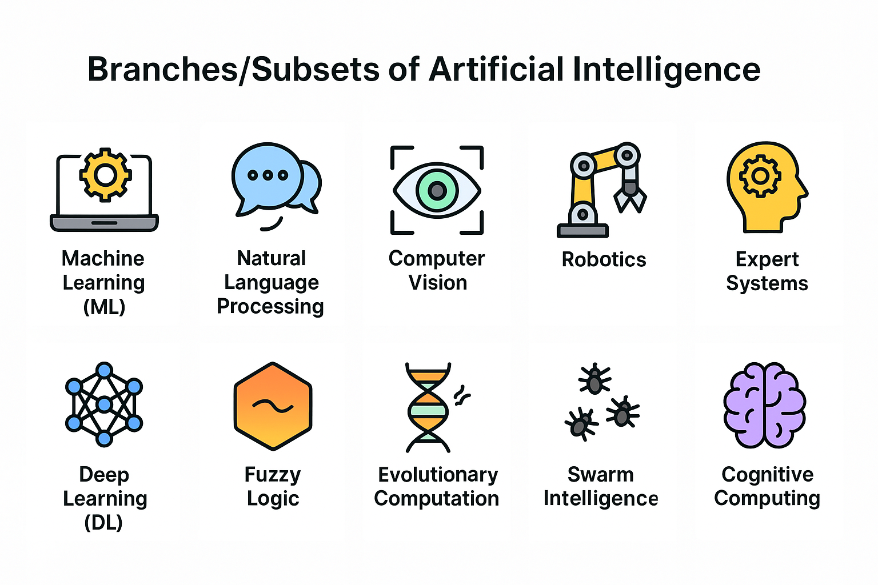

# **Chapter 2:**

# **Machine Learning (ML)**

Machine Learning (ML) is a branch of Artificial Intelligence that allows computers to learn from data and make decisions or predictions without being explicitly programmed for each task. Instead of giving the machine step-by-step instructions, we give it examples. The machine finds patterns and learns how to respond to similar situations in the future.

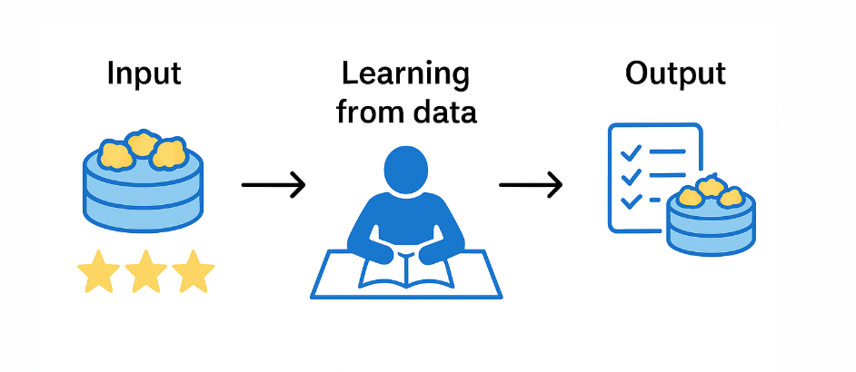

# **A Simple Analogy**

Machine Learning is like teaching a robot to bake by showing it dozens of cakes and telling it which ones tasted good and which ones didn’t. Instead of giving it a fixed recipe, you let the robot analyze the ingredients, baking times, and results from each cake.

Over time, it learns patterns for example, that adding more sugar makes the cake softer and tastier and uses that knowledge to create a better recipe on its own. It doesn’t just follow instructions; it learns from data and improves with experience.

# **Types of Machine Learning**

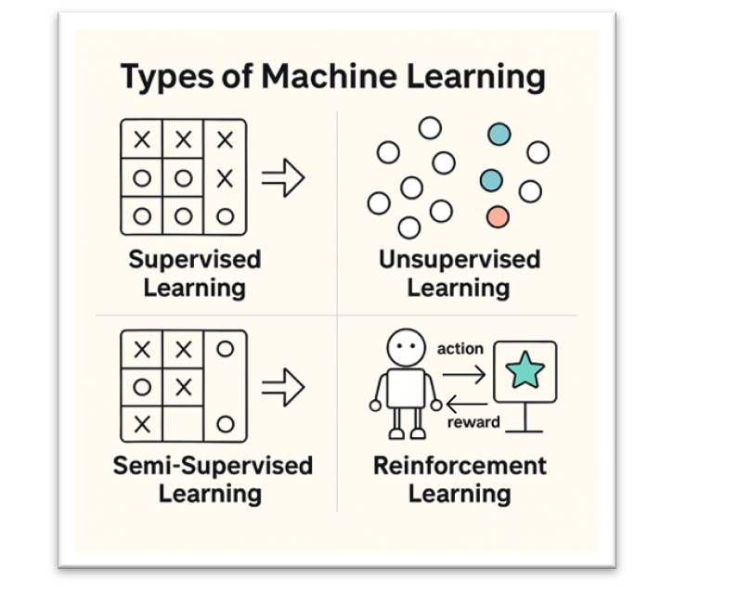

# **1. Supervised Learning**

Supervised learning is a type of machine learning where the model learns from **labeled data**. Each input data point is paired with a corresponding label (or output), and the model tries to learn the relationship between the input and output.

**How it works:**

1. The model is trained on a dataset with **inputs (X)** and **outputs (Y)**.
2. It learns a function **f(X) = Y** to predict the output for new, unseen inputs.

**Example Use Cases:**

* **Classification**: Email spam detection (spam vs. not spam)
* **Regression**: Predicting house prices based on features like size, location, etc.

**Common Algorithms:**

* Linear Regression (for regression tasks)
* Logistic Regression (for binary classification)
* Decision Trees, Random Forests
* Support Vector Machines (SVM)

**Input Data:** Labeled (input-output pairs).

**Output:** Predicts a label or value for new data points.

# **2.Unsupervised Learning**

Unsupervised learning is used when the data has **no labels**. The model tries to **find patterns, structure, or relationships** in the data on its own.

**How it works:**

1. The model receives only the **input data (X)** without any labels.
2. It identifies underlying structures, clusters, or groupings in the data.

**Example Use Cases:**

* **Clustering**: Customer segmentation in marketing
* **Anomaly Detection**: Fraud detection in financial transactions
* **Dimensionality Reduction**: Reducing large datasets to 2D or 3D for visualization (e.g., PCA)

**Common Algorithms:**

* K-Means Clustering
* Hierarchical Clustering
* DBSCAN (Density-Based Spatial Clustering)
* Principal Component Analysis (PCA) for dimensionality reduction

**Input Data:** Unlabeled (only input data, no labels).

**Output:** Finds groups, patterns, or reduces the data's dimensions.

# **3.Semi-Supervised Learning**

Semi-supervised learning is a hybrid approach that uses a mix of **labeled and unlabeled data**. Usually, only a small portion of the data is labeled, while the rest is unlabeled.

**How it works:**

1. A small part of the data is labeled, while the majority is unlabeled.
2. The model learns from the labeled data but also tries to learn patterns from the unlabeled data.

This approach is useful when labeling data is expensive or time-consuming (like in medical images, where only experts can label the data).

**Example Use Cases:**

* **Medical Image Analysis**: Diagnosing diseases from medical images (CT, MRI) where only a few images are labeled.
* **Webpage Classification**: Classifying millions of web pages where only a small set of pages is labeled.

**Common Algorithms:**

* Self-Training (uses predictions on unlabeled data as pseudo-labels)
* Generative models like Variational Autoencoders (VAEs)
* Graph-Based Semi-Supervised Learning

**Input Data:** A mix of labeled and unlabeled data.

**Output:** Predictions on the unlabeled data after learning from both labeled and unlabeled data.

# **4.Reinforcement Learning**

Reinforcement learning (RL) is a **trial-and-error learning approach** where an agent learns by interacting with an environment. The agent performs actions and receives feedback (rewards or penalties) that it uses to improve its behavior over time.

**How it works:**

1. The agent observes the current **state** of the environment.
2. It takes an **action** and receives a **reward** or **penalty** from the environment.
3. The agent's goal is to **maximize total cumulative reward**.

This process is inspired by human and animal learning, where actions are reinforced if they result in positive outcomes.

**Example Use Cases:**

* **Robotics**: Teaching a robot how to walk or balance
* **Game AI**: Training AI to play games like Chess, Go, or Dota 2
* **Autonomous Vehicles**: Teaching self-driving cars to navigate streets

**Common Algorithms:**

* Q-Learning (simple form of RL)
* Deep Q-Networks (DQN)
* Policy Gradient Methods (like REINFORCE)
* Actor-Critic Methods

**Input Data:** Feedback from the environment (state, action, reward).

**Output**: A policy (set of rules) for taking actions in the environment.

# **Tasks of Machine Learning**

In Machine Learning, a task refers to the problem or objective that a model is designed to solve. Each task corresponds to a specific goal, like classifying emails as spam, predicting house prices, or detecting fraudulent transactions. These tasks are linked to the type of learning (supervised, unsupervised, or reinforcement learning) and determine which algorithm and model to use.

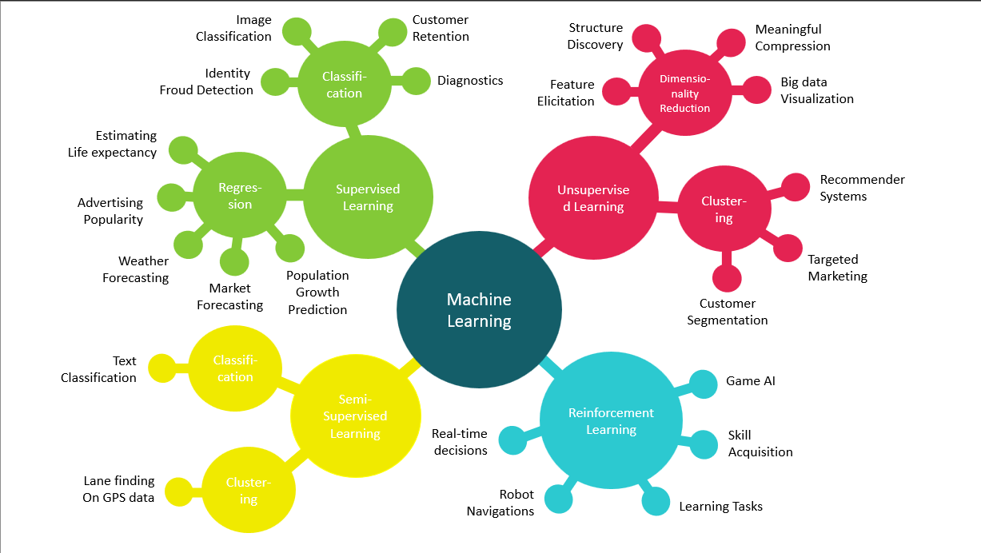

# **1. Classification**

**Task Objective**: Classify input data into predefined categories or classes.

**How it works:**

* Given a labeled dataset (input + output), the model predicts the class (or label) of new, unseen inputs.
* It tries to find decision boundaries to separate classes.

**Types of Classification:**

* **Binary Classification**: Two possible outcomes (e.g., "Spam" or "Not Spam").
* **Multi-class Classification**: More than two possible outcomes (e.g., classifying animals as "Dog", "Cat", or "Bird").
* **Multi-label Classification**: Each instance can have multiple labels (e.g., an image might be labeled as "sunset" and "beach").

**Example Use Cases:**

* **Spam detection**: Classify emails as spam or not spam.
* **Sentiment analysis**: Classify customer reviews as positive, neutral, or negative.
* **Medical diagnosis**: Classify patients as "diseased" or "not diseased".
* **Object recognition**: Recognize objects in images, like cats vs. dogs.

**Algorithms Used:**

* Logistic Regression
* Decision Trees
* Random Forest
* Support Vector Machines (SVM)

# **2. Regression**

**Task Objective**: Predict a **continuous numerical value** (not a category or label).

**How it works:**

* Instead of predicting classes, regression predicts a continuous number.
* The model learns the relationship between input features and a numerical target variable.

**Types of Regression:**

* **Linear Regression**: Predict a straight-line relationship between input and output.
* **Polynomial Regression**: Models more complex, curved relationships.

**Example Use Cases:**

* **House price prediction**: Predict the price of a house based on its size, location, etc.
* **Stock price prediction**: Predict future stock prices based on historical data.
* **Weather forecasting**: Predict temperature, humidity, or rainfall.
* **Customer lifetime value (CLV)**: Predict how much a customer will spend over their lifetime.

**Algorithms Used:**

* Linear Regression
* Ridge Regression
* Lasso Regression
* Decision Trees
* Neural Networks (Deep Learning)

# **3. Clustering**

**Task Objective**: **Group similar data points into clusters** based on patterns.

**How it works:**

* Unlike classification, clustering works with **unlabeled data**.
* The model groups data points into clusters based on similarity or distance (like Euclidean distance).

**Types of Clustering:**

* **K-Means Clustering**: Divides data into "k" clusters, where "k" is predefined.
* **Hierarchical Clustering**: Builds a tree of clusters, merging or splitting them step by step.
* **DBSCAN**: Groups data into clusters and identifies anomalies (outliers).

**Example Use Cases:**

* **Customer segmentation**: Group customers into similar segments (for marketing purposes).
* **Anomaly detection**: Detect unusual patterns, such as fraudulent transactions.
* **Image segmentation**: Divide an image into regions (like dividing an image into foreground and background).

**Algorithms Used:**

* K-Means Clustering
* Hierarchical Clustering
* DBSCAN (Density-Based Spatial Clustering)

# **4. Dimensionality Reduction**

**Task Objective**: Reduce the **number of features** in a dataset while preserving as much information as possible.

**How it works:**

* In datasets with high-dimensional data (like images or gene sequences), dimensionality reduction reduces the number of features.
* It makes computation faster and easier to visualize the data.

**Types of Dimensionality Reduction:**

* **Principal Component Analysis (PCA)**: Projects data into fewer dimensions while preserving variance.
* **t-SNE (t-distributed Stochastic Neighbor Embedding)**: Used for visualizing high-dimensional data.
* **UMAP**: Similar to t-SNE but faster and better for larger datasets.

**Example Use Cases:**

* **Data visualization**: Reduce dimensions to 2D or 3D for visualization.
* **Feature extraction**: Extract only the most important features for training models.
* **Image compression**: Reduce the size of an image dataset by representing it with fewer dimensions.

**Algorithms Used:**

* Principal Component Analysis (PCA)
* t-SNE
* UMAP

# **5. Anomaly Detection**

**Task Objective**: Identify **unusual or rare events** in data.

**How it works:**

* Anomaly detection models identify data points that **don't fit normal patterns**.
* It is used for detecting **outliers**, like fraudulent transactions.

**Types of Anomalies:**

* **Point Anomalies**: An individual data point is abnormal (like a fraudulent bank transaction).
* **Contextual Anomalies**: A data point may be normal in one context but abnormal in another (like a spike in website traffic).
* **Collective Anomalies**: A group of data points is considered abnormal (like a denial-of-service attack).

**Example Use Cases:**

* **Fraud detection**: Identify fraudulent credit card transactions.
* **Cybersecurity**: Detect abnormal network traffic (like a cyber attack).
* **Industrial monitoring**: Detect faults in equipment or sensor readings.

**Algorithms Used:**

* Isolation Forest
* One-Class SVM
* Autoencoders (Unsupervised Neural Networks)

# **6. Recommendation Systems**

**Task Objective**: Suggest items or products based on user preferences or past behavior.

**How it works:**

* Recommendation systems use historical user interactions to recommend similar products, movies, or books.
* They predict a user's rating for an item (like recommending movies on Netflix).

**Types of Recommendation Systems:**

* **Collaborative Filtering**: Recommends items based on the behavior of similar users.
* **Content-Based Filtering**: Recommends items similar to those the user liked in the past.
* **Hybrid Systems**: Combine collaborative and content-based filtering.

**Example Use Cases:**

* **E-commerce**: Product recommendations (like Amazon's "People also bought" section).
* **Streaming services**: Netflix, YouTube, and Spotify recommend content.
* **Online learning**: Suggests courses or learning resources.

**Algorithms Used:**

* Matrix Factorization (like SVD)
* Collaborative Filtering (user-based, item-based)
* Neural Collaborative Filtering (Deep Learning)

# **Chapter 3:**

# **Algorithms in Machine Learning**

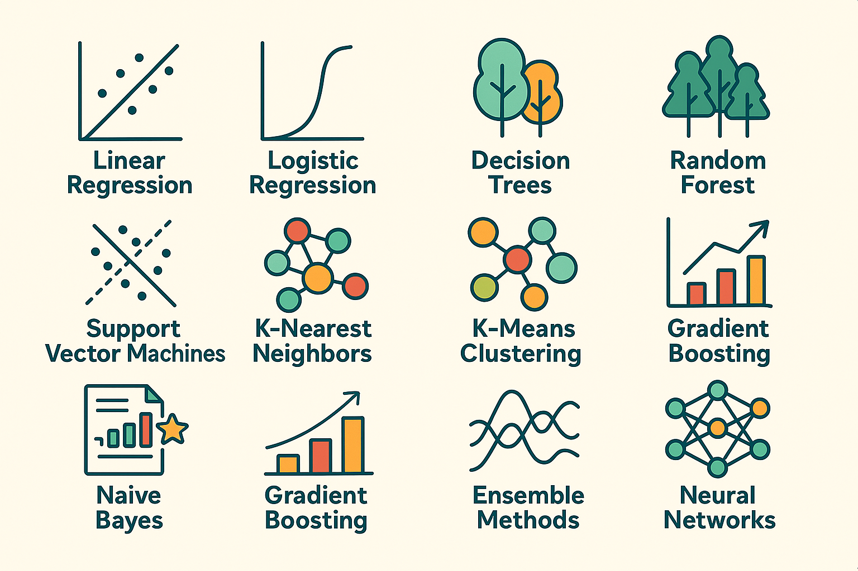

In **Machine Learning**, an **algorithm** is a set of instructions or mathematical procedures used to create a model that can learn patterns from data and make predictions or decisions. Instead of explicitly programming the model with fixed rules, the algorithm **learns the rules automatically** by training on data.

In simpler terms:

* **Traditional programming**: You give the system rules + data → It produces the output.
* **Machine learning**: You give the system data + output → It learns the rules (the algorithm finds the pattern).

Machine Learning algorithms are categorized based on the **type of learning** (Supervised, Unsupervised, and Reinforcement Learning) and **the specific task** (like classification, regression, clustering, etc.).

# **Types of Algorithms in Machine Learning**

# **1. Linear Regression**

**Type:** Supervised (Regression)

**Idea**: Draw a straight line through the data that best predicts the output. The model assumes a linear relationship between input variables (features) and the output (target).

**How it works:**

* The algorithm tries to find the line (y = mx + b) that minimizes the difference between predicted and actual values.
* It uses a method called "least squares" to reduce errors.

**Analogy:** Like drawing the best-fitting straight line through a cloud of dots on a graph.

**Use Cases:**

* Predicting house prices
* Estimating product demand
* Salary prediction based on experience

**Limitations:**

* Doesn’t work well if the relationship is not linear.
* Sensitive to outliers.

# **2. Logistic Regression**

**Type:** Supervised (Classification)

**Idea:** Estimates the probability that something belongs to a class using a mathematical function called the sigmoid.

**How it works:**

* Outputs a value between 0 and 1 that represents the probability of a data point belonging to a class.
* Often used for binary classification (yes/no problems).

**Analogy:** Like flipping a switch based on a threshold: above 0.5 means “yes”, below 0.5 means “no.”

**Use Cases:**

* Email spam detection
* Predicting customer churn (leave or stay)
* Loan default prediction

**Limitations:**

* **Assumes a linear decision boundary.**
* **Not ideal for complex relationships.**

# **3. Decision Trees**

**Type:** Supervised (Classification/Regression)

**Idea:** Splits the data into branches based on decisions, forming a tree-like structure. Each branch represents a decision rule.

**How it works:**

* Starts at the root and asks a series of yes/no questions.
* Each answer leads to another question or a final prediction (leaf).

**Analogy:** Like playing 20 Questions or following a flowchart.

**Use Cases:**

* Diagnosing diseases based on symptoms
* Customer segmentation

**Strengths:**

* Easy to interpret and visualize
* Handles both numerical and categorical data

**Weaknesses:**

* Prone to overfitting
* Can become complex with too much data

# **4. Random Forest**

**Type:** Supervised (Classification/Regression)

**Idea:** Combines many decision trees to form a “forest” and makes a prediction based on the average (regression) or majority vote (classification).

**How it works:**

* Each tree is trained on a random sample of the data.
* Introduces randomness in feature selection to reduce overfitting.

**Analogy:** Like asking a group of people for an answer and trusting the majority opinion.

**Use Cases:**

* Credit scoring
* Fraud detection
* Disease diagnosis

**Strengths:**

* Robust and accurate
* Handles large datasets and many features

**Weaknesses:**

* Less interpretable than a single decision tree
* Slower to make predictions

# **5. Support Vector Machines (SVM)**

**Type:** Supervised (Classification)

**Idea:** Finds the best line (or hyperplane) that separates classes of data with the widest possible margin.

**How it works:**

* Identifies the boundary that best divides the classes.
* Uses a mathematical technique called a “kernel” to work in high-dimensional spaces.

**Analogy:** Like stretching a rubber band tightly to separate two groups of points.

**Use Cases:**

* Face recognition
* Text classification
* Bioinformatics

**Strengths:**

* Effective in high-dimensional spaces
* Works well with clear margin of separation

**Weaknesses:**

* Computationally intensive on large datasets
* Sensitive to the choice of kernel and parameters

# **6. K-Nearest Neighbors (K-NN)**

**Type:** Supervised (Classification/Regression)

**Idea:** Classifies a data point based on the majority vote or average of its 'k' nearest neighbors.

**How it works:**

* Calculates distance between the new point and all others in the training data.
* Selects the 'k' closest points and uses them to predict the label.

**Analogy:** Like asking your closest friends for advice and going with the most common suggestion.

**Use Cases:**

* Handwriting recognition
* Recommendation systems

**Strengths:**

* Simple and effective
* No training needed (lazy learner)

**Weaknesses:**

* Slow with large datasets
* Sensitive to the choice of 'k' and feature scaling

# **7. K-Means Clustering**

**Type:** Unsupervised (Clustering)

**Idea:** Divides the data into “k” groups (clusters) based on similarity.

**How it works:**

* Picks k random points as cluster centers (centroids).
* Assigns each point to the nearest centroid.
* Recalculates the centroids and repeats until stable.

**Analogy:** Like sorting similar-looking marbles into different boxes.

**Use Cases:**

* Market segmentation
* Organizing documents or images
* Identifying patterns in social media data

**Strengths:**

* Simple and fast
* Easy to implement

**Weaknesses:**

* Need to choose k manually
* Sensitive to initial position of centroids

# **8. Principal Component Analysis (PCA)**

**Type:** Unsupervised (Dimensionality Reduction)

**Idea:** Reduces the number of input variables while keeping the most important information.

**How it works:**

* Identifies directions (called principal components) where the data varies the most.
* Projects the data onto those directions.

**Analogy:** Like compressing a big book into a summary without losing the key ideas.

**Use Cases:**

* Visualizing high-dimensional data
* Removing noise from signals
* Preprocessing before applying other models

**Strengths:**

* Speeds up training time
* Helps avoid overfitting

**Weaknesses:**

* Can be hard to interpret
* Assumes linear relationships

# **9. Naive Bayes**

**Type:** Supervised (Classification)

**Idea:** Uses probability and Bayes’ theorem, assuming that features are independent.

**How it works:**

* Calculates the probability of each class given the input features.
* Chooses the class with the highest probability.

**Analogy:** Like predicting a movie’s genre based on keywords in the description.

**Use Cases:**

* Spam filtering
* Sentiment analysis
* Document categorization

**Strengths:**

* Very fast and scalable
* Works well with text data

**Weaknesses:**

* Assumes feature independence (which is rarely true)

# **10. Gradient Boosting (e.g., XGBoost, LightGBM)**

**Type:** Supervised (Classification/Regression)

**Idea:** Builds multiple models in sequence, each one correcting the mistakes of the previous one.

**How it works:**

* Combines weak learners (like small decision trees) into a strong model.
* Optimizes the performance by minimizing error step-by-step.

**Analogy:** Like several teachers reviewing the same test, with each focusing on the errors left by the previous.

**Use Cases:**

* Credit scoring
* Sales prediction
* Winning data science competitions

**Strengths:**

* Very accurate and powerful
* Handles missing data and many features well

**Weaknesses:**

* Computationally expensive
* More complex to tune

# **11. Ensemble Methods**

**Type:** Technique (used in combination with other algorithms)

**Idea:** Combines predictions from multiple models to improve overall performance.

**How it works:**

* Can average predictions (regression) or vote on them (classification).
* Types include Bagging (e.g., Random Forest), Boosting (e.g., XGBoost), and Voting Classifiers.

**Analogy:** Like gathering advice from multiple experts before making a final decision.

**Use Cases:**

* Any classification or regression task where high accuracy is desired

**Strengths:**

* Reduces overfitting
* More robust and stable than individual models

**Weaknesses:**

* Harder to interpret
* Increased computational complexity

# **12. Neural Networks (Basic)**

**Type:** Supervised (Classification/Regression)

**Idea:** Mimics the way the human brain works using layers of nodes (neurons) that process information.

**How it works:**

* Information moves from the input layer, through hidden layers, to the output layer.
* The model adjusts the weights of connections during training to minimize error.

**Analogy:** Like a brain made of digital neurons that learn by adjusting their connections.

**Use Cases:**

* Image and speech recognition
* Medical diagnosis
* Natural Language Processing (NLP)

**Strengths:**

* Very powerful with large datasets
* Can model complex, non-linear relationships

**Weaknesses:**

* Requires a lot of data and computing power
* Difficult to interpret (black box)

# **Data sets**

A dataset is simply a collection of data. Think of it as a big table, like an Excel spreadsheet where:

* Each **row** represents an example or an observation (like a person, an image, or a product).
* Each **column** represents a feature or property of that example (like name, age, price, or category).

Machine learning models learn from datasets by analyzing the patterns and relationships between inputs (features) and outputs (labels or targets).

**Types of Datasets in Machine Learning**

**1️.Based on Data Structure**

**Structured Data**

* Organized in rows and columns (like a spreadsheet or SQL table)
* Example: Name, Age, Income

Used in classical ML algorithms (e.g., decision trees, regression)

**Unstructured Data**

* No fixed format; raw and messy
* Example: Text, Images, Audio, Video

Used in Deep Learning (e.g., CNNs, RNNs, Transformers)

**Semi-Structured Data**

* Has some organization, but not strictly tabular
* Example: JSON files, XML, log files

Used in hybrid applications like text mining, web scraping

**2️.Based on Label Availability**

**Labeled Dataset**

* Each example has an input and a target output (label)
* Example: Image of a dog labeled as “dog”

Used in **Supervised Learning** (classification, regression)

**Unlabeled Dataset**

* Contains only input data without labels
* Example: A collection of product reviews with no sentiment tags

Used in **Unsupervised Learning** (clustering, dimensionality reduction)

**Partially Labeled (Semi-Supervised)**

* A small portion of the data is labeled, most is unlabeled
* Example: 100 labeled images out of 10,000 total

Used in **Semi-Supervised Learning**

**3️.Based on Usage in the ML Pipeline**

**Training Set**

* Used to train the model

**Validation Set**

* Used to tune hyperparameters and prevent overfitting

**Test Set**

* Used to evaluate final model performance

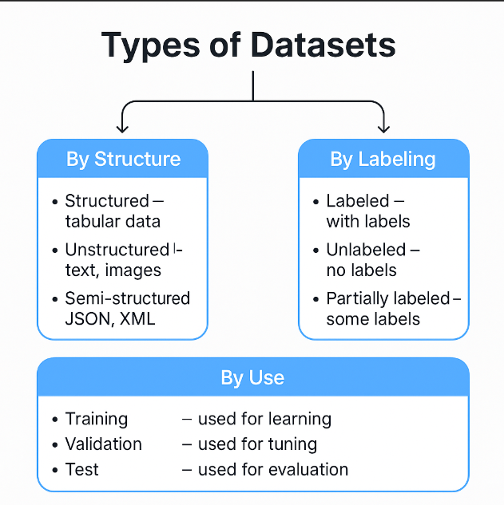

# **Modules**

Modules in Machine Learning refer to **libraries** or **frameworks** that contain **pre-implemented** machine learning algorithms, utilities, and tools for data processing, model training, evaluation, and deployment. These modules save time because they provide ready-to-use implementations instead of requiring developers to build models from scratch.

**Why are they important?**

Without modules, you would have to write every algorithm and tool from scratch — which would be slow, error-prone, and not scalable.

With modules, you can:

* Train a model in a few lines of code
* Focus on solving real problems, not reinventing the wheel
* Use battle-tested, optimized implementations

**Types of Modules in Machine Learning**

**1. Data Handling Modules**

For loading, cleaning, transforming, and manipulating data.

* **pandas** – for working with tabular data (DataFrames)
* **NumPy** – for numerical operations with arrays and matrices
* **OpenCV, PIL** – for processing images
* **os, glob, pathlib** – for managing files and directories

**2️. Data Visualization Modules**

For understanding patterns and distributions in the data.

* **matplotlib** – basic plotting
* **seaborn** – statistical plots
* **plotly** – interactive visualizations
* **yellowbrick** – ML-specific visual diagnostics

**3️. Model Building & Training Modules**

To build, train, and test ML models.

* **scikit-learn** – classic ML algorithms (regression, classification, clustering)
* **TensorFlow / Keras** – deep learning models
* **PyTorch** – flexible deep learning framework
* **XGBoost / LightGBM** – powerful tree-based algorithms

**4️. Model Evaluation & Tuning Modules**

For assessing performance and improving models.

* **scikit-learn.metrics** – accuracy, precision, recall, etc.
* **GridSearchCV / RandomizedSearchCV** – hyperparameter tuning
* **cross_val_score** – cross-validation evaluation

**5️. Deployment & Serving Modules**

For deploying models into real applications.

* **Flask / FastAPI** – building APIs to serve models
* **TensorFlow Serving / ONNX** – model serving frameworks
* **joblib / pickle** – saving and loading trained models

**Popular ML Modules:**

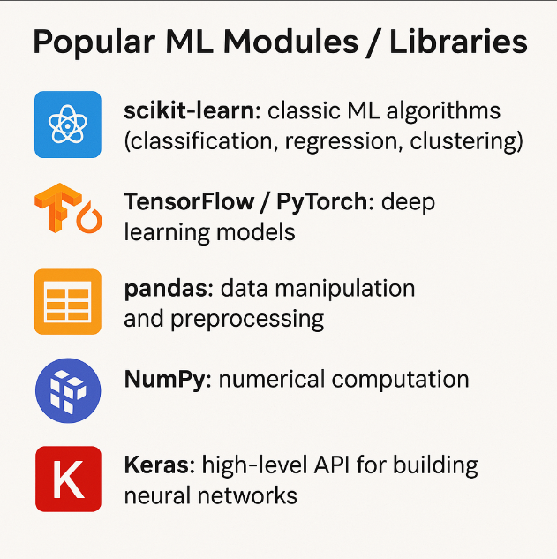

# **Models**

A model in machine learning is the final product of the learning process. It’s what the computer uses to make predictions or decisions based on the data it has learned from. Think of a model as a recipe that was created after observing thousands of cooking attempts now, it knows the right ingredients and steps to create a great dish!

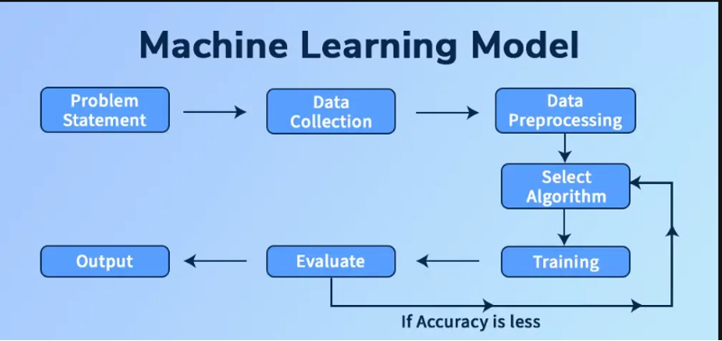

**Types of Models in Machine Learning**

**1. Geometric Models**

These models represent data in a geometric space and use distance, margins, or hyperplanes to separate classes or make predictions.

* **Examples**: Linear Regression, Logistic Regression, Support Vector Machines (SVM), K-Nearest Neighbors (K-NN)
* **Use cases**: Classification, regression, visual data separation

Think of drawing a line or surface to separate categories of points in a graph.

**2. Probabilistic Models**

These models are based on **probability theory**. They model the likelihood of outcomes and can handle uncertainty and noisy data well.

* **Examples**: Naive Bayes, Bayesian Networks, Hidden Markov Models (HMM)
* **Use cases**: Natural Language Processing (NLP), spam detection, risk analysis

They answer: “What is the probability that this belongs to category X?”

**3. Logical Models**

These models use **logical rules** or symbolic reasoning. They often work with “if... then...” rules and are **easy to interpret**.

* **Examples**: Decision Trees, Rule-Based Systems, Expert Systems
* **Use cases**: Medical diagnosis, decision support systems

Great for explainability. You can ask: “Why did the model predict this?”

**4. Grouping and Grading Models**

These models either **group similar data points (clustering)** or **rank items (grading)**.

* **Examples**: K-Means, DBSCAN (clustering); PageRank, Recommendation systems (ranking)
* **Use cases**: Customer segmentation, content recommendation, social network analysis

Helpful when you don’t have labels or want to prioritize choices.

# **Model Evaluation**

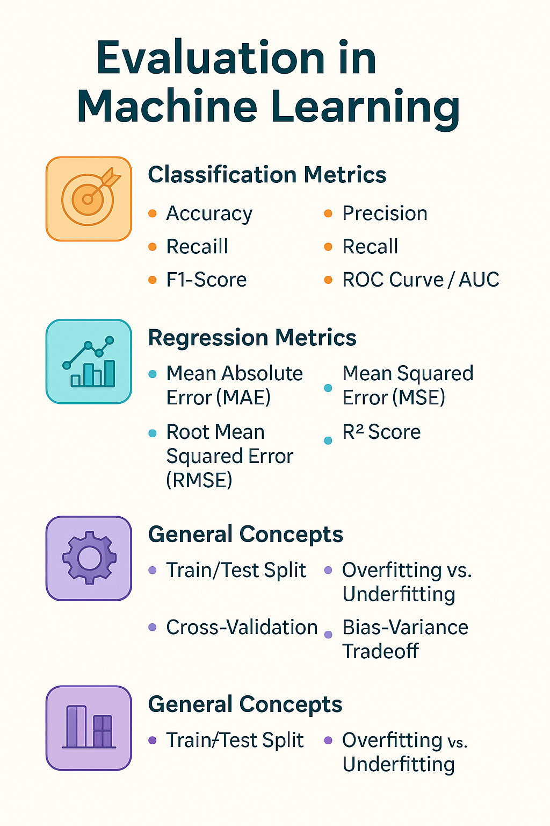

# **1. Classification Metrics**

Once you've trained a machine learning model, how do you know if it’s good? That’s where evaluation metrics come in they help you measure how well the model performs.

## **Accuracy**

Measures how many predictions your model got right.

**Formula:**  
Accuracy = (Correct Predictions) / (Total Predictions)

**Example:** If your model correctly classified 90 out of 100 emails, the accuracy is 90%.

**Caution:** Accuracy can be misleading with **imbalanced data**. For example, if 95% of emails are “not spam,” a model that always predicts “not spam” will have 95% accuracy — but it's useless!

## **Precision**

Out of everything the model predicted as **positive**, how many were actually correct?

**Formula:**  
Precision = True Positives / (True Positives + False Positives)

**Example:** If your model says 10 emails are spam, and 7 really are, precision = 70%.

Used when **false positives** are expensive (e.g., flagging a legit email as spam).

## **Recall**

Out of all the actual **positive cases**, how many did the model catch?

**Formula:**  
Recall = True Positives / (True Positives + False Negatives)

**Example:** If there are 10 spam emails, and your model finds 7, recall = 70%.

Used when **missing positives is costly** (e.g., failing to detect a disease).

## **F1-Score**

A balance between precision and recall — useful when you want a trade-off.

**Formula:**  
F1 = 2 × (Precision × Recall) / (Precision + Recall)

**Why it matters:** It gives a **single score** that considers both false positives and false negatives.

## **Confusion Matrix**

A table that shows exactly how the model performed — what it got right and wrong.

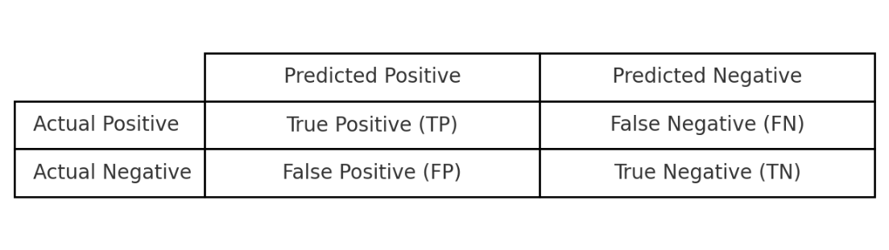

## **ROC Curve / AUC**

* **ROC Curve (Receiver Operating Characteristic):** Plots the trade-off between **True Positive Rate (Recall)** and **False Positive Rate**.
* **AUC (Area Under the Curve):** Measures the overall ability of the model to distinguish between classes.

AUC ranges from **0 to 1**, where:

* 0.5 = random guess
* 1.0 = perfect classifier

# **2. Regression Metrics**

## **Mean Absolute Error (MAE)**

Measures the average **absolute difference** between predicted and actual values.

**Formula:**  
MAE = average(|y_true - y_pred|)

Simple and interpretable — errors in same units as output.

## **Mean Squared Error (MSE)**

Same as MAE, but **squares the errors** — so larger errors are penalized more.

**Formula:**  
MSE = average((y_true - y_pred)²)

Useful when large errors are especially bad.

## **Root Mean Squared Error (RMSE)**

The square root of MSE — brings the error back to original units.

**Formula:**  
RMSE = √MSE

Preferred when you want the error in the same scale as the predicted value.

## **R² Score**

Measures how well your model explains the variance in the data.

**Formula:**  
R² = 1 - (Sum of Squared Errors / Total Sum of Squares)

* R² = 1 → Perfect prediction
* R² = 0 → Model predicts as poorly as the average
* R² < 0 → Worse than average prediction

# **3. General Concepts**

## **Train/Test Split**

Divide your dataset into two parts:

* **Training set** → used to train the model
* **Test set** → used to evaluate it

Typically: 70–80% training, 20–30% testing.

This prevents your model from being tested on the same data it learned from.

## **Cross-Validation**

Instead of a single train/test split, the data is divided into **k folds**.

* The model is trained on k–1 folds and tested on the remaining fold.
* This repeats k times, and the results are averaged.

**Why?** More reliable results, especially with small datasets.

## **Overfitting vs. Underfitting**

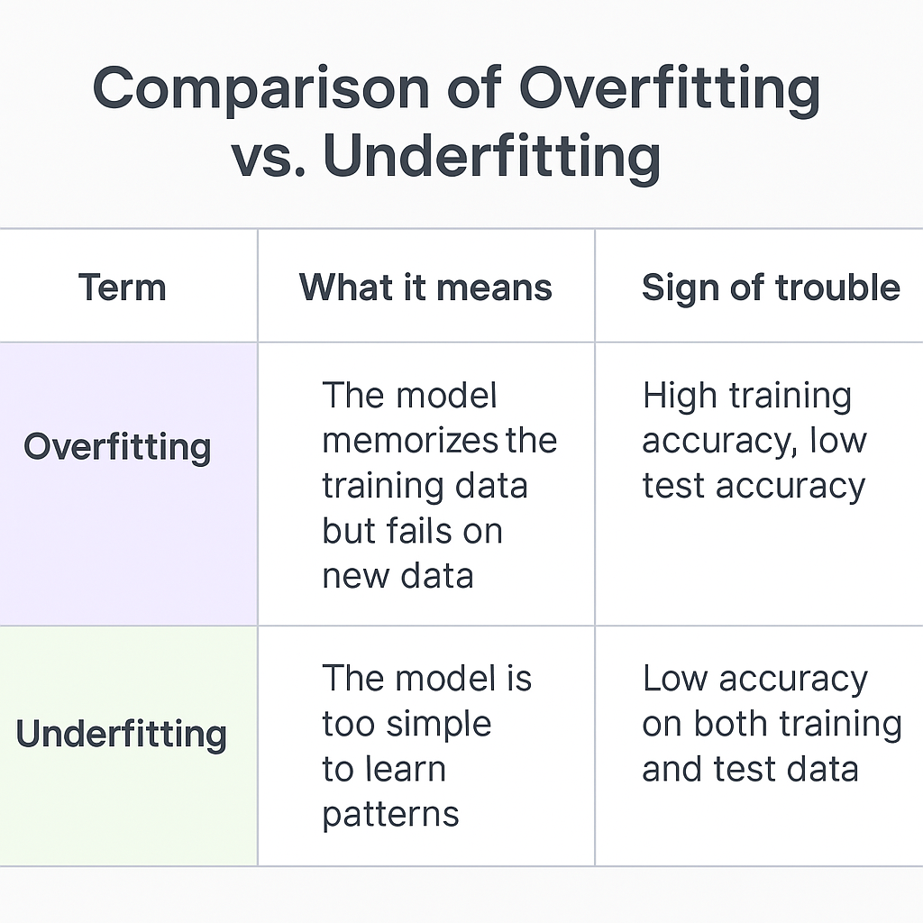

## **Bias-Variance Tradeoff**

The **core dilemma** in machine learning. You want a model that **generalizes well**, not too simple, not too complex.

* **Bias**: Error due to overly simplistic assumptions (underfitting)
* **Variance**: Error due to being too sensitive to training data (overfitting)

**Goal:** Find the balance.

**Algorithm Vs. Dataset Vs. Module Vs. Model**

When learning about machine learning, it's common to feel overwhelmed by technical terms like algorithm, dataset, module, and model. While these concepts are frequently mentioned, beginners often struggle to understand how they truly connect e.g., what comes first, what depends on what, and what each one actually *does* in practice.

To simplify, imagine you're baking a cake. Just like in the kitchen, where each step and tool contributes to the final result, machine learning also follows a process where each component plays a unique and essential role:

* The **algorithm** is the recipe or cooking method, it defines *how* to combine and transform ingredients.
* The **dataset** is the collection of ingredients, the raw materials the model learns from.
* The **module** (library/framework) is your kitchen equipment, tools like mixers and measuring cups that help implement your recipe efficiently.
* And the **model** is the cake, the final product that results from following the recipe using the right tools and ingredients.

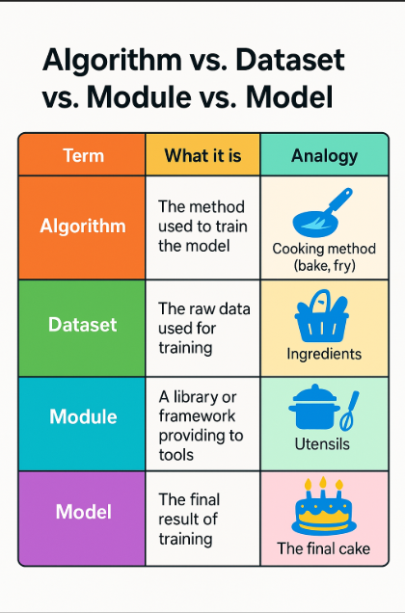

# **Chapter 4:**

# **How a Machine Learning Project Works**

Understanding the theory is great, but how do you actually do a Machine Learning project in real life? This chapter walks you through each step of a typical ML workflow. Think of it as a roadmap, from raw data to a working model that can make predictions.

# **1.Define the Problem**

Before jumping into data, ask:

* What problem are we trying to solve?
* What decision do we want the model to help us make?
* Is it a classification, regression, or clustering task?

**Example:** Predict whether a customer will cancel their subscription.

# **2.Collect the Data**

You need data to teach the model. This can come from:

* Spreadsheets (CSV files)
* Databases (SQL, NoSQL)
* APIs (e.g., Twitter, weather services)
* Sensors or logs (IoT, web activity)

**Tip:** The more relevant and clean the data, the better the model will perform.

# **3. Explore the Data (EDA - Exploratory Data Analysis)**

Before building a model, you need to understand the data:

* What features (columns) do we have?
* Are there missing values?
* What are the data types (numbers, text, categories)?
* Do we see any obvious patterns or outliers?

**Tools used:** Pandas, Matplotlib, Seaborn (Python libraries)

**Example:** Creating histograms or scatter plots to visualize relationships.

# **4. Prepare the Data**

Raw data usually needs cleaning and transformation:

* Handle missing data (remove or fill in)
* Convert text into numbers (encoding)
* Normalize or scale features
* Split data into training and testing sets

**Why?** Models work better with clean, structured, and numerical data.

# **5. Choose a Model**

Now choose the right algorithm based on your task:

* Classification → Logistic Regression, Decision Tree, SVM
* Regression → Linear Regression, Random Forest
* Clustering → K-Means, DBSCAN

Start simple. Fancy doesn’t always mean better.

# **6. Train the Model**

Now it’s time to teach the model using your training data.

* The model learns patterns and relationships.
* It creates internal rules to make predictions.

**Example:** Training a model to recognize handwritten digits by feeding it thousands of labeled images.

# **7. Evaluate the Model**

We test the model on unseen (testing) data to check how well it learned.

**Metrics depend on the task:**

* Accuracy (for classification)
* Mean Squared Error (for regression)
* Confusion Matrix, Precision, Recall, F1-Score (for deeper insights)

If performance is poor, go back to improve the data, try a different model, or adjust parameters.

# **8. Improve the Model (Optional but common!)**

Refining your model can include:

* Tuning hyperparameters (like learning rate, tree depth, etc.)
* Using better features (feature engineering)
* Trying more advanced algorithms (e.g., ensembles, deep learning)

**Tools used:** GridSearchCV, cross-validation

# **9. Deploy the Model**

Once the model performs well, it can be deployed:

* Integrated into an app, website, or internal system
* Used to make real-time or batch predictions

**Example:** A trained spam filter model gets added to your email platform.

# **10. Monitor and Maintain**

Even after deployment, you need to:

* Monitor performance over time
* Retrain with new data when necessary
* Handle concept drift (when patterns change over time)

**Remember:** Machine Learning is not "train once and forget" — it’s an ongoing process.

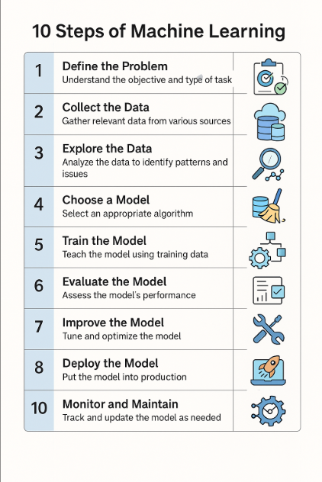

# **Chapter 5:**

# **Deep Learning (DL)**

Deep Learning is a subset of Machine Learning that uses artificial neural networks with multiple layers (called "deep" networks) to learn and extract complex patterns from large amounts of data. Unlike traditional machine learning, which requires manual feature extraction, deep learning models can automatically discover and extract relevant features from raw data.

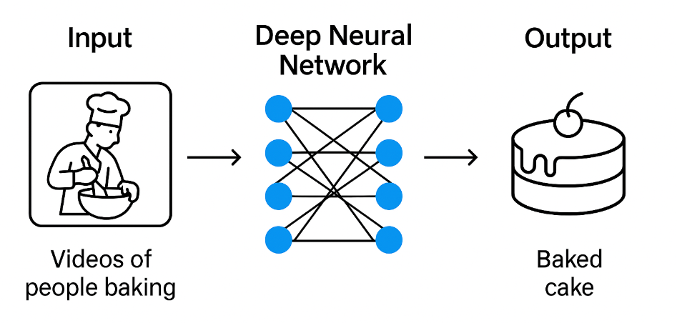

# **A Simple Analogy**

Deep Learning is like watching thousands of videos of people baking cakes, without ever reading a recipe. Instead of being told the steps, the system observes, learns patterns, and figures out how to make a cake just by analyzing the process visually.

Over time, it becomes so good at recognizing the ingredients, mixing techniques, and baking time that it can bake a cake on its own even better than some who follow the recipe. Just like this, deep learning models learn directly from raw data like images, audio, or text, discovering complex patterns without manual feature extraction.

# **Why Deep Learning Is Not a Main Type of Machine Learning?**

# **1.Difference in Purpose**

* The main types of Machine Learning (Supervised, Unsupervised, and Reinforcement Learning) define how the learning process happens — whether the model learns from labeled data, unlabeled data, or through interaction with the environment.
* Deep Learning, on the other hand, refers to how the model is built. It’s a technique or methodology for building and training models, not a distinct "way of learning" like the others.
* Deep Learning models are usually implemented using deep neural networks with multiple layers that extract hierarchical features from data.

# **2.Hierarchical Relationship**

* **Supervised, Unsupervised, and Reinforcement Learning** are at a higher conceptual level. They define the nature of the learning process itself.
* **Deep Learning** is a more specialized subset of **Machine Learning methods** that can be applied **within those main paradigms**. For example:
  + In **Supervised Learning**, you can use logistic regression, decision trees, or deep neural networks (deep learning).
  + In **Unsupervised Learning**, you can use clustering (like k-means) or **deep learning models** like autoencoders.
  + In **Reinforcement Learning**, you can use traditional Q-learning or modern **Deep Q-Networks (DQN)**.
* This shows that Deep Learning can be applied **inside each of the major types**, not in parallel with them.

# **3.Focus on Model Architecture, Not Learning Process**

* Supervised, Unsupervised, and Reinforcement Learning describe the **type of data and feedback** used to train a model.
* Deep Learning describes the **type of model architecture** (deep neural networks) used to implement those types.
* To understand this, think of **deep learning as a tool or approach** to solve problems in supervised, unsupervised, and reinforcement learning, while the "types of learning" are the strategy or paradigm.

# **4.Historical and Practical Context**

* Originally, before the rise of Deep Learning, Machine Learning was mainly associated with classical models like SVMs, decision trees, and clustering algorithms.
* **Deep Learning emerged as a breakthrough method**, but it did not introduce a new "type" of learning. Instead, it became a revolutionary technique for achieving better results in existing categories (like supervised and reinforcement learning).
* Deep Learning became a "subset" rather than a "main type" because it didn't change the core concept of how the model learns — it changed **how we build and train the model**.

# **When to Use Deep Learning?**

Use Deep Learning when:

* You have a large amount of data
* The task involves images, audio, video, or natural language
* You need high accuracy and can afford more computation

**Examples:**

* Face recognition in photos
* Voice assistants like Siri and Alexa
* Automatic translation between languages
* Detecting diseases from medical scans

# **How Do Neural Networks Learn?**

A neural network is made of layers of **neurons** (also called nodes), organized in:

* **Input layer**: Takes in raw data
* **Hidden layers**: Perform mathematical operations
* **Output layer**: Produces the prediction

Each connection has a weight. The model adjusts these weights during training to reduce the error. This process is called **backpropagation**.

**Analogy:** Like a team of workers passing messages through a pipeline, refining the information at each step.

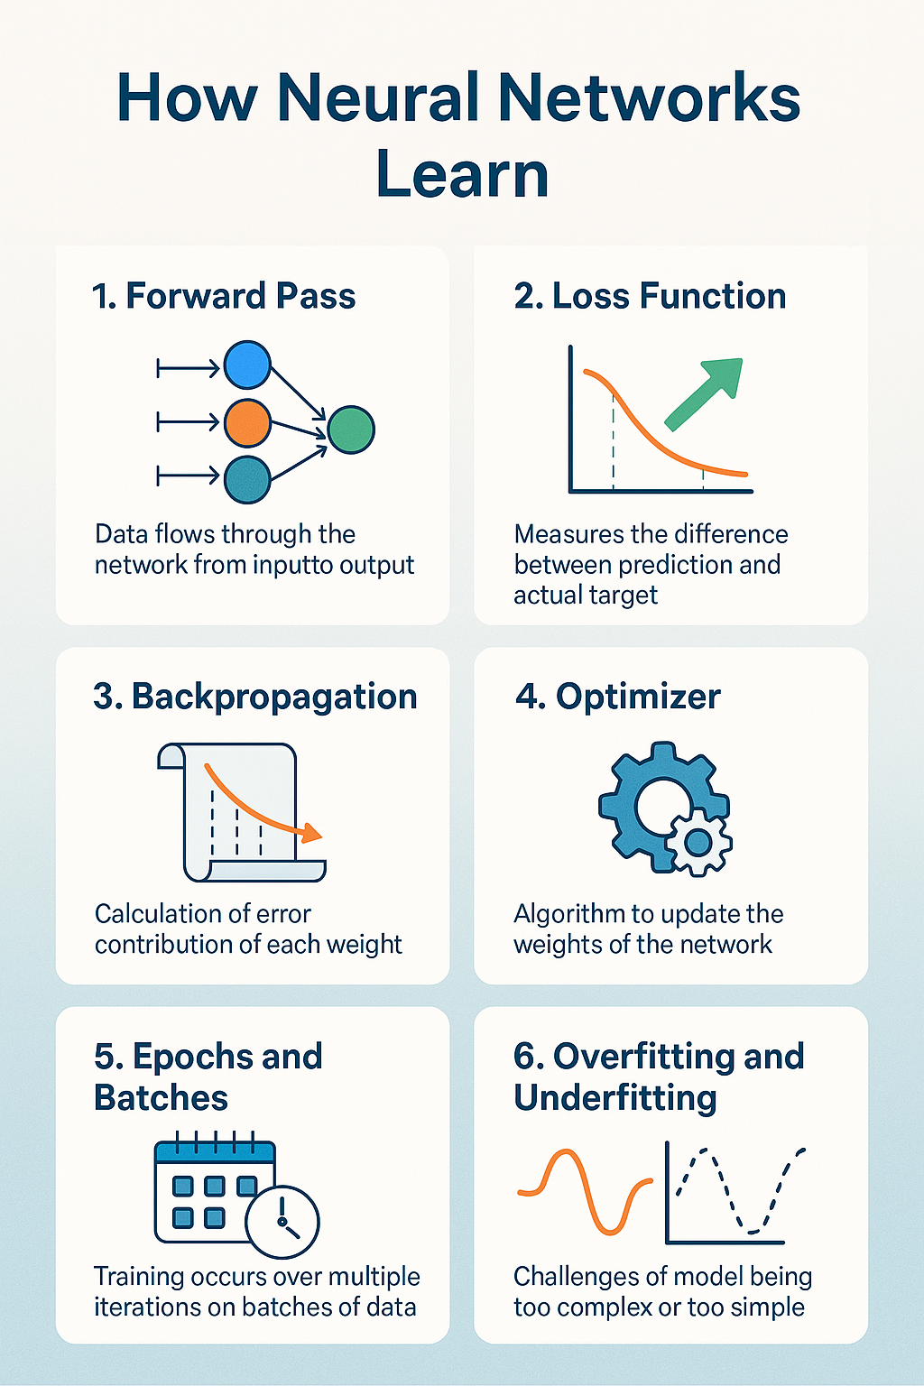

# **1. Forward Pass**

This is the first step in training. Data flows through the network—from the input layer, through hidden layers, to the output layer.

**What happens:**

* Each neuron receives inputs, multiplies them by weights, adds a bias, and applies an activation function.
* The output is passed to the next layer.

**Goal:** Make a prediction based on current weights.

**Analogy:** Like a machine going through a recipe to produce a result based on current instructions.

# **2. Loss Function**

After the network makes a prediction, it compares the result to the actual target (the correct answer).

The **loss function** measures how far off the prediction was.

**Common loss functions:**

* Mean Squared Error (MSE) – for regression
* Cross-Entropy – for classification

**Goal:** The lower the loss, the better the model.

# **3. Backpropagation**

Now the network knows how wrong it was. It needs to adjust.

**Backpropagation** is the process of calculating how much each weight contributed to the error.

**How it works:**

* The error is sent backward through the network.
* Each weight is updated based on its contribution to the error.

**Analogy:** Like reviewing your steps after making a mistake to see where things went wrong.

# **4. Optimizer**

Once the network knows how to adjust, it uses an **optimizer** to actually update the weights.

**Popular optimizers:**

* Gradient Descent
* Stochastic Gradient Descent (SGD)
* Adam (Adaptive Moment Estimation)

**Goal:** Find the best weights that minimize the loss.

# **5. Epochs and Batches**

Training doesn’t happen in one step—it happens over many **epochs**.

* **Epoch:** One full pass through the entire training dataset.
* **Batch:** A small group of examples processed together.
* **Mini-batch gradient descent:** Combines speed and stability by processing small batches instead of the whole dataset at once.

**Goal:** Improve the model with each epoch.

# **6. Overfitting and Underfitting**

**Overfitting:** The model learns the training data *too well*, including noise and random patterns. It performs poorly on new data.

**Underfitting:** The model is too simple to capture the patterns in the data.

**Solutions for overfitting:**

* Use more data
* Simplify the model
* Apply **regularization** (like L1/L2)
* Use **dropout** (randomly turning off neurons during training)

# **Chapter 6:**

# **Types of Deep Learning Models**

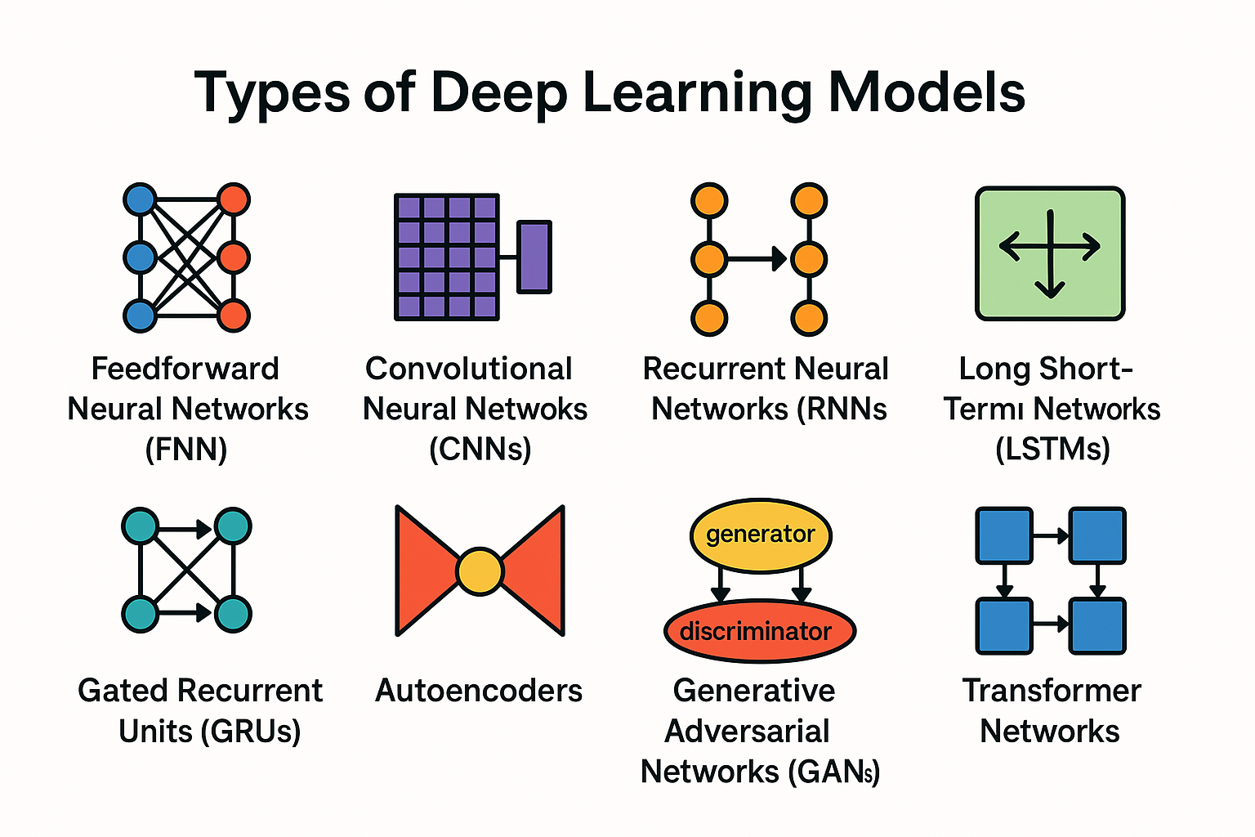

In deep learning, there are many different types of neural network architectures. At first glance, they might all seem very similar after all, they’re all neural networks, they all have layers, they all “learn from data’’. But in reality, each of these architectures was developed to solve a specific kind of problem or to overcome a limitation of the models that came before.

Some are better at handling images. Some are designed for sequential data like text or time series. Some are made to generate new content or compress information. And some like Transformers are powerful generalists, but require heavy resources and are not always the most efficient choice. Understanding the differences between these models isn't about memorizing names it’s about recognizing which tool is best suited to which task.

## **1.Feedforward Neural Networks (FNN)**

Feedforward Neural Networks (FNNs) are the simplest and most foundational type of neural network. They are called “feedforward” because data flows in a single direction from input to output without any loops or memory. They are ideal for tasks where inputs are independent of each other (i.e., there is no time sequence or context involved).

**FNNs in Context**

FNNs are the building block of deep learning. While they may not perform well on complex problems like language modeling or image segmentation, they are perfect for:

* Learning basic concepts
* Benchmarking algorithms
* Serving as the foundation for more advanced models

**Use Cases:**

* + Predicting numeric values ( e.g., estimating housing prices, predicting sales)
  + Simple classification tasks (e.g., recognizing handwritten digits (MNIST), detecting spam vs. not spam)
  + Basic Image Recognition ( classifying small, low-complexity images)
  + Regression and Binary Classification ( modeling basic input-output relationships)

## **2. Convolutional Neural Networks (CNNs)**

Convolutional Neural Networks (CNNs) are a type of deep neural network specially designed to process grid-like data such as images, where pixels are arranged in rows and columns. They are highly effective at recognizing visual patterns, like edges, textures, shapes, and objects. CNNs automatically learn which features are important, without needing manual extraction.

**Use Cases:**

* Image classification (e.g., cats vs. dogs)
* Object detection ( identifying and locating multiple objects in an image e.g., faces, vehicles)
* Medical image analysis (e.g., X-rays)
* Handwriting Recognition (recognizing digits or letters in scanned documents)
* Video Frame Analysis ( detecting movement or classifying content in video streams)

## **3. Recurrent Neural Networks (RNNs)**

Recurrent Neural Networks (RNNs) are a type of neural network specialized for sequential data where the order of inputs matters, like time series, natural language, or audio. What makes RNNs unique is their ability to remember past information using internal loops, allowing them to maintain a “memory” of previous inputs while processing the current one.

**How RNNs Work**

Unlike traditional feedforward networks, RNNs have connections that loop back on themselves. This structure allows information to be passed from one step in the sequence to the next.

At each time step:

* The network takes the current input
* Combines it with the previous hidden state (memory)
* Produces an output and an updated memory

This makes them ideal for tasks where context or order matters like predicting the next word in a sentence or forecasting a stock price based on historical trends.

**Limitations of RNNs**

Despite their usefulness, basic RNNs have major limitations:

* Struggle with long-term dependencies they "forget" earlier inputs over time.
* Training difficulties prone to vanishing or exploding gradients, which makes learning unstable.

These weaknesses led to the development of more advanced architectures like LSTMs and GRUs.

**Use Cases:**

* Sentiment analysis ( classifying movie or product reviews as positive or negative based on word sequence)
* Language modeling ( predicting the next word or character in a sentence)
* Stock price prediction ( forecasting future values based on historical trends)
* Speech Recognition ( transcribing spoken words into text over time)

## **4. Long Short-Term Memory Networks (LSTMs)**

LSTMs are a special type of Recurrent Neural Network (RNN) designed to handle long-term dependencies meaning they can remember information from much earlier in a sequence than standard RNNs. They're especially powerful when the current decision depends not just on the last input, but on inputs that came much earlier.

**Why Were LSTMs Created?**

Standard RNNs suffer from two major issues:

* Vanishing gradients – they forget long-term dependencies.
* Short memory – they focus mostly on recent inputs.

LSTMs solve this by adding a memory cell and gates that help the network decide:

* What to remember
* What to forget
* What to output

**Use Cases:**

* Speech recognition ( understanding spoken language in context)
* Text generation ( writing new text word by word, like auto-completing a sentence or writing a poem)
* Machine translation (translating full sentences while preserving structure and meaning  
  e.g., English → French, Chinese → Spanish)
* Music Composition ( generating note sequences or rhythms)
* Time Series Forecasting ( predicting future trends in sequential data)

## **5. Gated Recurrent Units (GRUs)**

Gated Recurrent Units (GRUs) are a type of recurrent neural network specifically designed to work with sequential data, such as text, time series, or audio. They were introduced as a simplified alternative to LSTMs (Long Short-Term Memory networks), offering similar performance with a lighter architecture and faster training.

**Why Use GRUs?**

* Efficient: require fewer parameters than LSTMs
* Accurate: perform well in practice for many sequence-based tasks
* Flexible: can be used in the same scenarios as LSTMs and RNNs

**Use Cases:**

* Language modeling ( predicting the next word or character in a sentence)
* Time-series forecasting ( predicting future values e.g., stock prices, weather, energy usage)
* Chatbots and speech-to-text systems (understanding spoken or typed language over time)
* Music Generation & Recommendation ( predicting song sequences, user listening behavior)

## **6. Autoencoders**

Autoencoders are a type of unsupervised neural network designed to learn efficient representations of input data often for tasks like compression, reconstruction, or anomaly detection.

They work by encoding the input into a smaller, dense representation (called the latent space) and then trying to decode or reconstruct the original input as closely as possible.

**Why Are Autoencoders Important?**

* They learn without labels suitable for unsupervised learning
* They capture core patterns and can ignore noise
* They can detect outliers or abnormal behavior that doesn’t match the learned patterns

**Use Cases:**

* Image denoising ( removing noise from blurry or corrupted images)
* Anomaly detection ( identifying fraudulent transactions, system faults, or rare events by spotting poor reconstructions)
* Dimensionality reduction ( reducing the number of features while retaining meaning an alternative to PCA)
* Bioinformatics & Healthcare ( finding patterns in gene expressions or medical images)
* Sensor Data Compression (reducing the volume of time-series data while preserving signal)

## **7. Generative Adversarial Networks (GANs)**

Generative Adversarial Networks (GANs) are one of the most creative and fascinating innovations in deep learning. They consist of two neural networks that compete against each other:

* **Generator**: tries to create fake data that looks real (e.g., realistic images)
* **Discriminator**: tries to detect whether data is real or fake

This setup forms a “game” between the two:

* The generator improves by learning to fool the discriminator.
* The discriminator improves by getting better at spotting fake data.

Over time, both networks get smarter until the generator produces data that is almost indistinguishable from real examples.

**How GANs Work (Simplified)**

1. Generator creates a fake image (e.g., a human face).
2. Discriminator receives both a real and fake image.
3. It predicts which is real and which is fake.
4. Both networks adjust based on whether the discriminator was fooled.

Think of it like a forger vs. a detective:

* The forger (generator) keeps making better fakes.
* The detective (discriminator) keeps sharpening their eye.

**Use Cases:**

* Creating realistic images or art ( are used to generate portraits of people who don’t exist).
* Enhancing image resolution ( can transform low-quality photos into high-definition versions *super-resolution*).
* Generating synthetic data for training ( useful when real data is limited or sensitive e.g., in medical fields).
* Fashion & Design Prototyping ( generate new clothing designs or product ideas).
* Game Development ( generate landscapes, textures, or characters automatically).

## **8. Transformer Networks**

Transformers are a revolutionary type of neural network architecture designed specifically to handle sequential data like text, speech, or time series more efficiently than previous models like RNNs or LSTMs.

Instead of processing data step by step, Transformers use attention mechanisms to analyze all elements of a sequence at once. This parallel processing makes them faster, more powerful, and capable of capturing long-range dependencies in the data.

**Why Are Transformers So Powerful?**

* **Attention mechanism**: Allows the model to focus on the most relevant parts of the input, regardless of position.
* **Parallelism**: Unlike RNNs, Transformers can be trained on entire sequences in parallel — speeding up training significantly.
* **Scalability**: Excellent for training large models on massive datasets (like GPT or BERT).

**Popular Transformer-Based Models**

* **BERT (Bidirectional Encoder Representations from Transformers)** : Looks both left and right in a sentence to understand context. Useful for: *sentiment analysis, text classification, named entity recognition.*
* **GPT (Generative Pre-trained Transformer)** : Generates text one word at a time, based on previous context. Useful for: *chatbots, story generation, dialogue systems.*
* **T5 (Text-to-Text Transfer Transformer)** : Treats all NLP tasks as text-to-text problems, from translation to summarization.

**Use Cases of Transformers**

* Language Translation (e.g., English ↔ French)
* Chatbots and Virtual Assistants (e.g., ChatGPT, Alexa)
* Text Summarization (e.g., turning long articles into brief summaries)
* Question Answering (e.g., reading comprehension)
* Text Generation & Completion (e.g., auto-writing or completing emails)

# **Chapter 7:**

# **Real-World Applications**

# **1. Healthcare**

Machine Learning is transforming healthcare by enabling faster, more accurate diagnoses and personalized treatment plans.

**Applications:**

* Predicting disease outbreaks
* Diagnosing diseases from medical images (e.g., cancer detection from X-rays)
* Predictive analytics for patient risk assessment
* Drug discovery and genomics

**Example:**

* A CNN model can help radiologists detect tumors in MRI scans with high accuracy.

# **2. Finance**

ML helps financial institutions manage risk, detect fraud, and personalize services.

**Applications:**

* Fraud detection in transactions
* Credit scoring and loan approval
* Algorithmic trading
* Chatbots for customer service

**Example:**

* A supervised learning model can flag unusual spending behavior that might indicate fraud.

# **3. Transportation**

ML is at the heart of innovations in autonomous vehicles and route optimization.

**Applications:**

* Self-driving cars
* Traffic prediction and smart navigation
* Predictive maintenance for vehicles

**Example:**

* Reinforcement Learning helps self-driving cars make decisions in complex environments.

# **4. Retail and E-commerce**

ML helps companies understand customers better and improve user experience.

**Applications:**

* Product recommendations (based on purchase history)
* Dynamic pricing
* Customer segmentation
* Inventory forecasting

**Example:**

* Recommendation systems like "You may also like" are powered by collaborative filtering.

# **5. Marketing**

ML enables personalized marketing and better targeting of campaigns.

**Applications:**

* Predicting customer churn
* Personalizing email content
* Optimizing advertising budgets

**Example:**

* An ML model can decide which users are likely to click on an ad, improving ad performance.

# **6. Agriculture**

Smart farming uses ML for better crop yield and resource management.

**Applications:**

* Predicting crop diseases
* Monitoring soil and weather conditions
* Automating irrigation systems

**Example:**

* Image classification can help detect plant diseases early.

# **7. Manufacturing**

ML improves efficiency and reduces downtime.

**Applications:**

* Predictive maintenance
* Quality control through image recognition
* Demand forecasting

**Example:**

* ML models can predict when a machine is likely to fail and alert the technician in advance.

# **8. Education**

Adaptive learning platforms use ML to personalize content for students.

**Applications:**

* Automatic grading
* Personalized learning paths
* Dropout prediction

**Example:**

* An algorithm adjusts the difficulty of questions based on student performance.

# **9. Security**

ML strengthens digital and physical security systems.

**Applications:**

* Facial recognition for access control
* Intrusion detection systems
* Cybersecurity threat detection

**Example:**

* Anomaly detection models can identify unusual network activity.